Setting Up Application Environment Install IBM cloud CLI

|  |  |
| --- | --- |
| **Date** | **08 November 2022** |
| **Team ID** | **PNT2022TMID34253** |
| **Project Name** | **Skill and Job Recommended** |
| **Maximum Marks** | **2 marks** |

Step 1: Navigate to cloud.ibm.com

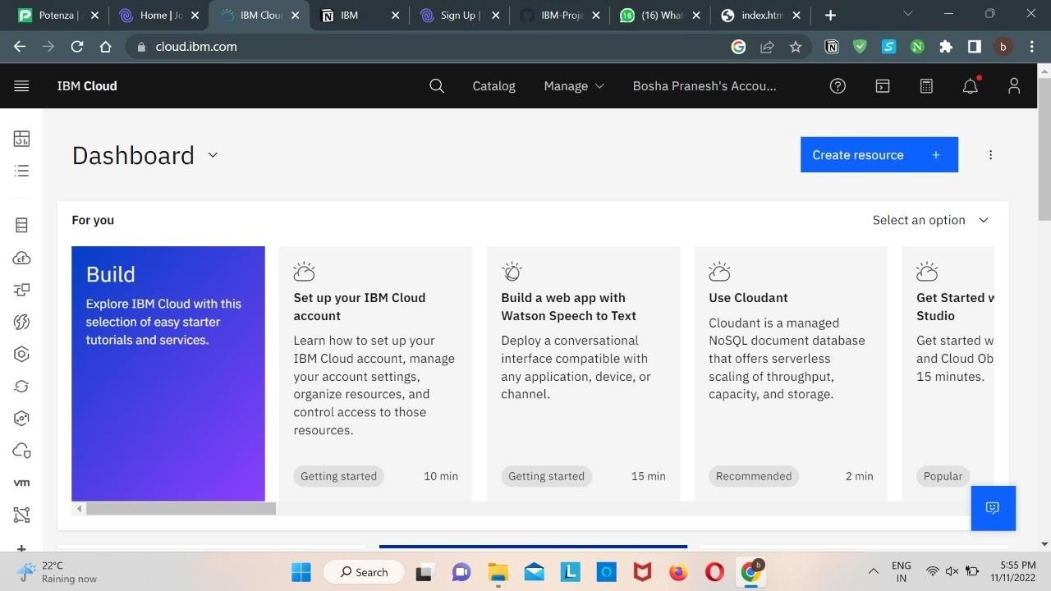

Step 2: Search on Container Registry and give get started and follow the steps to install IBM Cloud CLI

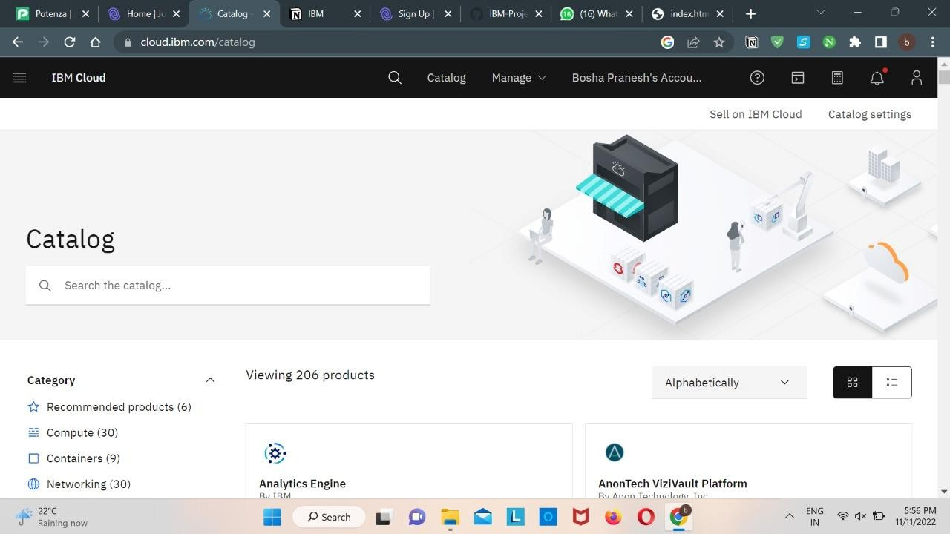

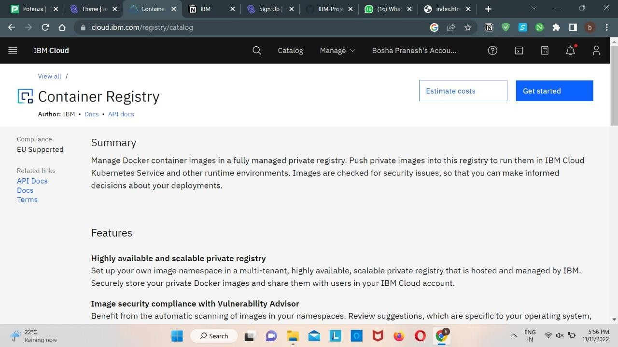

Step 3: Download windows 64-bit installer

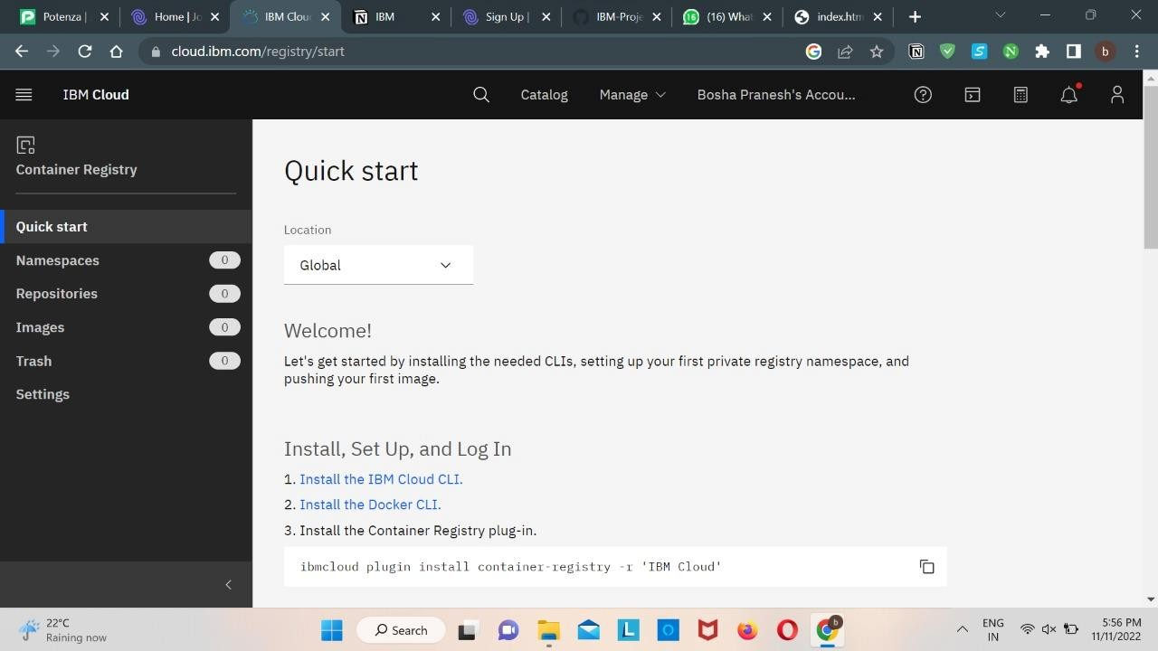

Step 4. Open the downloaded .exe file and run it to install IBM Cloud CLI

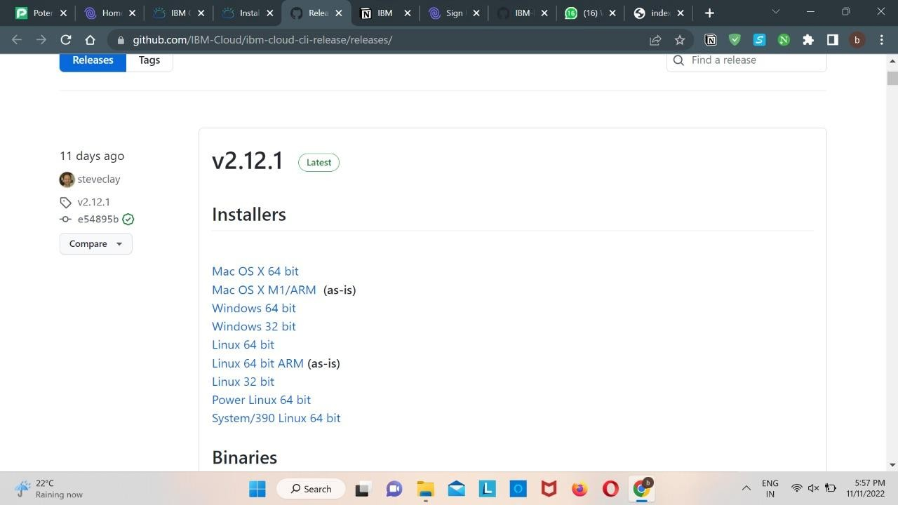

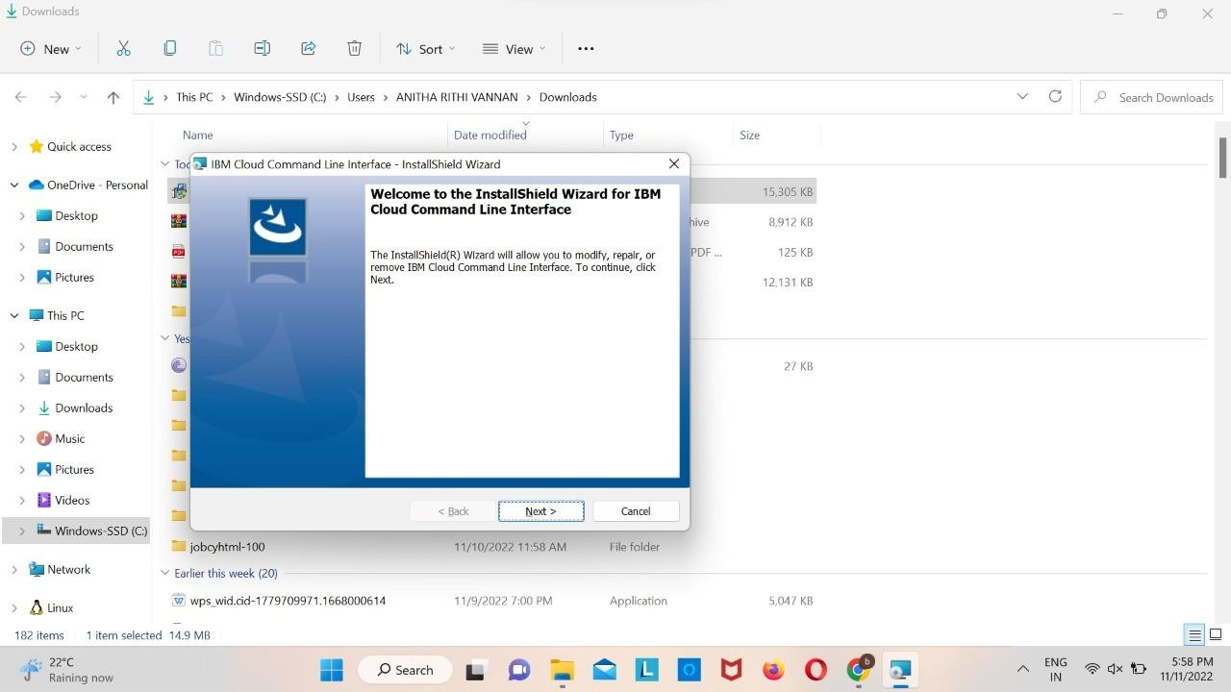

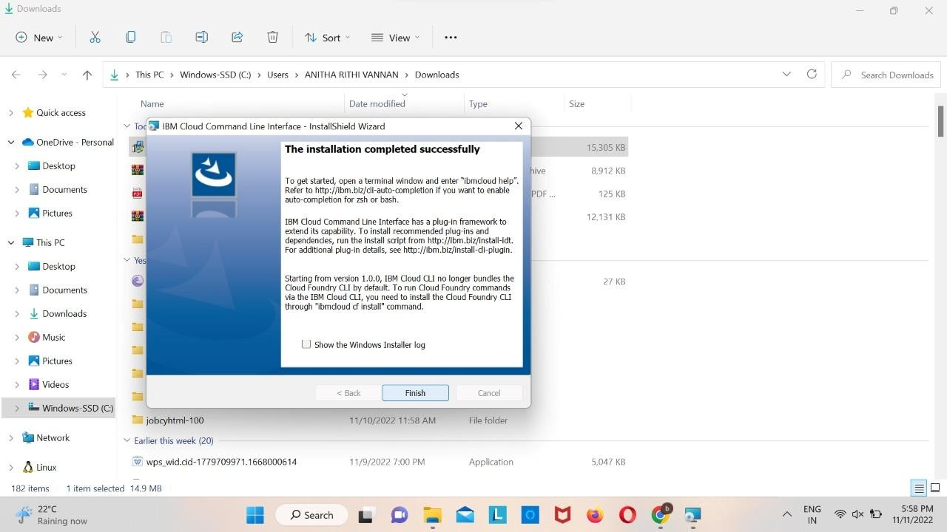

OUTPUT: IBM Cloud CLI is installed successfully